Smart Parking Management System
1 Background and Motivation
With the rapid growth of urban motor vehicle ownership, parking has become a major pain point in daily life. This issue is particularly acute in small and medium-sized scenarios such as university campuses, community parking lots, and office building garages.
Currently, most traditional or semi-automated parking management systems rely on simple gate controls and suffer from the following typical problems:
- Lack of Parking Space Transparency: Drivers cannot know the real-time status of parking spaces in advance and can only search blindly for empty spots. This exacerbates road congestion, increases unnecessary carbon emissions, and wastes time.
- Lack of Convenient Reservation Mechanism: Without an online reservation feature, users cannot plan their parking trips in advance, leading to frequent situations where users arrive to find no available spaces, resulting in a poor user experience.
- Lack of User-Side Convenience Functions: Vehicle owners cannot actively view or modify their vehicle information, nor can they quickly apply for long-term payment methods such as monthly parking passes.
- Isolated Data Management Silos: Parking records, user information, and billing data are often scattered across different systems or recorded manually. This makes unified statistics, analysis, and optimization difficult and hinders refined operational management.
Based on the above context, this project aims to develop a lightweight, multi-terminal collaborative smart parking management system. By integrating a Web Management Backend with a Web User Frontend, the system will implement functions such as real-time parking space monitoring, online reservations, data visualization, and automatic record retention. It specifically addresses the pain points of small and medium-sized parking scenarios, providing administrators and users with a convenient, efficient, and low-cost solution.
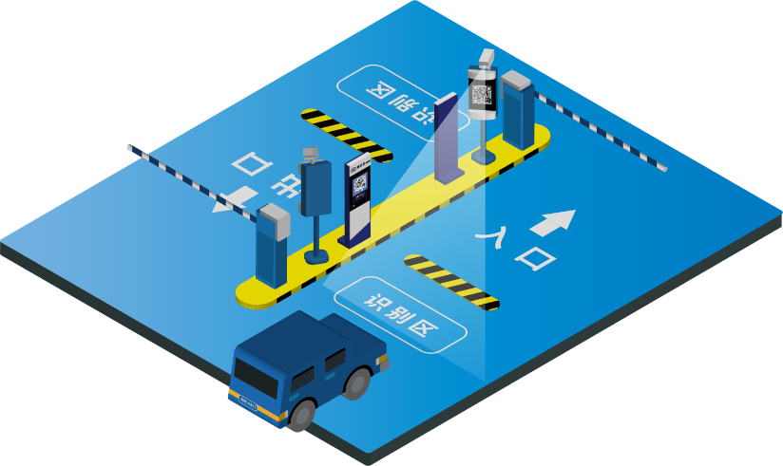
Fig1. Smart Parking Management System
2. System Objectives
The core objectives of this project are as follows:
- Build a Fully Web-Based Collaborative System: Develop an admin-facing backend management website and a user-facing frontend service website to ensure real-time data synchronization between both ends.
- Implement Full-Process Parking Management: Cover functions including parking space status display, vehicle entry/exit record management, online reservations, and order statistics to achieve a closed loop from query to settlement.
- Enhance Administrator Operational Efficiency: Provide a visual dashboard, automated data statistics, and one-click management tools to reduce manual operations and management errors.
- Improve User Convenience: Allow users to query available parking spaces in real-time, submit reservations, and view parking records via the website, eliminating the need for on-site queuing or blind searching.
- Ensure System Stability and Scalability: Adopt a modular design to ensure stable system operation under multi-user concurrent access and reserve interfaces for future functional expansions (e.g., electronic payments).
3. Project Solution Analysis
To ensure the smooth development and stable operation of the system, the following key technical and functional challenges must be addressed. Specific implementation plans are formulated for each issue to mitigate potential risks during development and application:
  - Real-time Data Synchronization Between Dual Ends
The admin web interface and the user web interface share the same MySQL database. Real-time data synchronization is the core guarantee for the normal operation of the dual-end collaborative system.
The key to solving this issue lies in a mechanism combining active push and passive pull: On one hand, when data changes on either end (e.g., parking space status, reservation info, entry/exit records), the backend server actively pushes the updated data to all online web clients via the WebSocket protocol, ensuring synchronization within 1-2 seconds. On the other hand, each web interface employs a timed polling mechanism (polling interval set to 5 seconds) to fetch the latest data from the database.
This effectively prevents data inconsistencies caused by network anomalies or push failures. Additionally, a data consistency verification mechanism is introduced.
Every 30 minutes, the system automatically compares key data between both ends and the database, correcting any inconsistencies to ensure data accuracy and reliability.
  - Reservation Conflict Handling
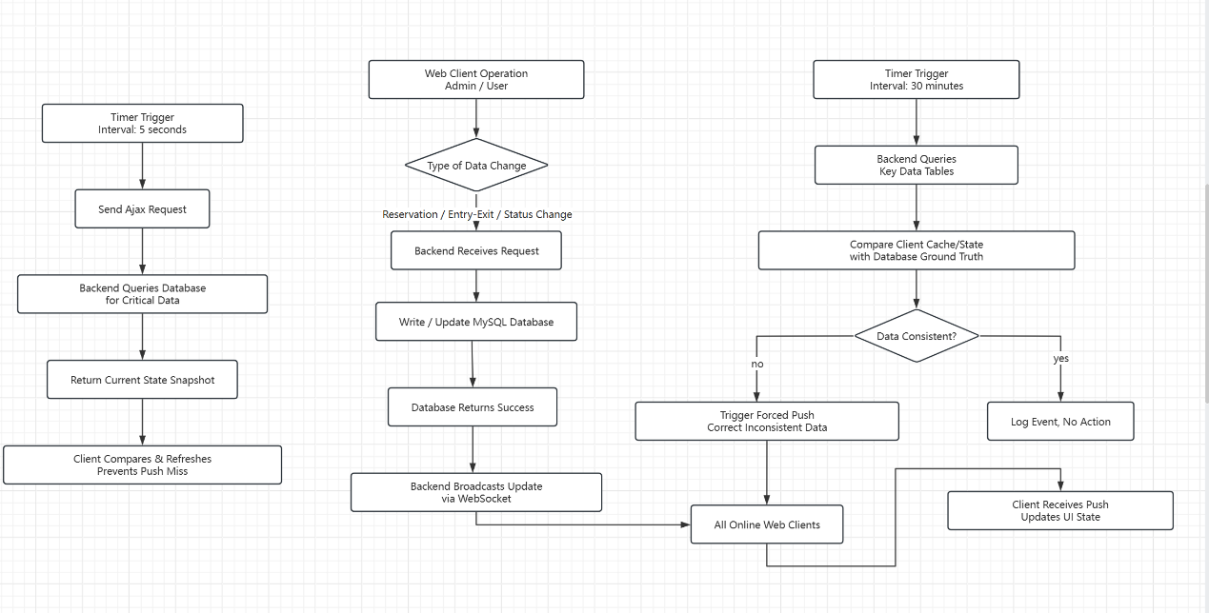
Fig2. Framework of Reservation
To address issues such as overbooking, duplicate reservations, and invalid bookings, a comprehensive reservation management logic is designed:
First, a reasonable reservation validity period is set. Users can reserve a space 1 to 24 hours in advance. The reservation remains valid for 30 minutes after the scheduled arrival time. If the user does not arrive within this validity window, the system automatically releases the reserved space to avoid resource waste.
Second, a real-time space locking mechanism is implemented. Once a user successfully reserves a space, the system immediately locks the corresponding space in the database and marks its status as "Reserved" in both the Admin Web Interface and the User Web Interface, preventing duplicate bookings by other users.
Third, a reservation conflict check is added. When a user submits a reservation request, the system queries the current status of the target space and existing reservation records. If the space is occupied or already reserved, the user is promptly notified and recommended alternative spaces, mitigating conflicts at the source.
Finally, reservation modification and cancellation functions are provided. Users can modify or cancel a reservation via the web interface up to 1 hour before the scheduled arrival time, and the system updates the space status in real-time upon completion.

  - Database Design and Performance Optimization
The database is the core of data storage and management; its design rationality and performance directly affect system efficiency.
First, a scientific data table structure is designed based on functional requirements, comprising 5 core tables: User Table (stores basic info, account credentials, vehicle details), Parking Space Table (stores space ID, location, status, type), Reservation Table (stores reservation ID, user ID, space ID, reservation time, validity period), Parking Record Table (stores entry time, exit time, duration, fee, user ID, vehicle info), and Operation Log Table (stores system operation records for future query and maintenance).
Second, appropriate indexes are added to key fields (e.g., User ID, Space ID, Reservation Time, Entry Time) of each data table to enhance query efficiency, reducing large data query times from seconds to milliseconds.
Third, the database connection pool is optimized with a reasonable pool size (adjustable based on concurrent users, typically 10-20 connections) to prevent slow responses or connection failures due to too many or too few connections.
Fourth, paginated queries are implemented for large datasets like parking records in both the Admin Web Interface and User Web Interface to minimize data transfer volume and improve interface responsiveness.
Furthermore, a regular database maintenance plan is established, including daily data backups, weekly index optimization, and monthly data cleanup to ensure database stability and performance.
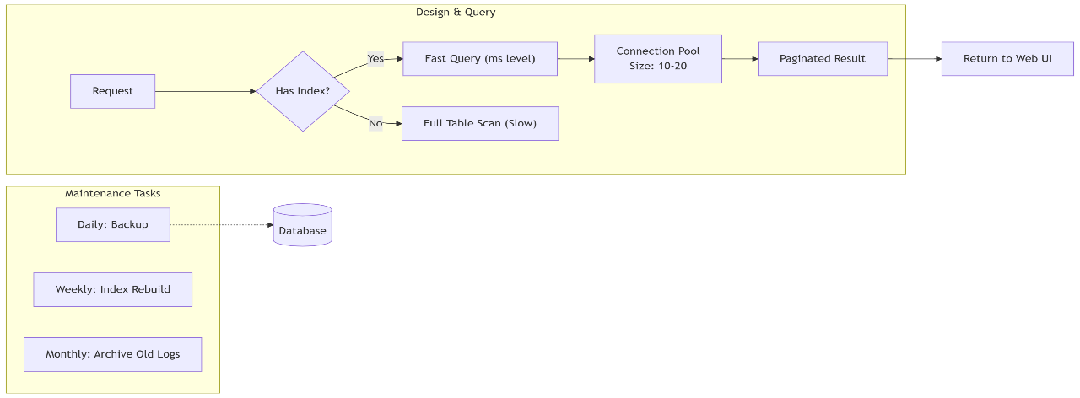

Fig3. Database Design

  - Interface Visualization Implementation
Visualization in the admin web interface is crucial for improving management efficiency. The key lies in dynamic data refreshing and intuitive display.
First, a visual parking space status interface is designed, simulating the actual layout of the parking lot. Using HTML5 Canvas or SVG technology combined with front-end frameworks, different colors mark the status of each parking space (green for available, red for occupied, yellow for reserved), displaying space ID and location information. The interface retrieves the latest data from the backend via WebSocket or timed Ajax polling and refreshes dynamically, allowing administrators to grasp the usage status of all spaces at a glance.
Second, statistical data visualization is implemented using front-end charting libraries such as ECharts or Chart.js to generate line charts, pie charts, and bar charts. These display daily, weekly, and monthly parking volumes, space utilization rates, and user reservation rates. Asynchronous requests and front-end component updates enable dynamic chart switching without page lag.
Third, a visual dashboard is designed for the admin web interface's main screen, integrating key metrics (e.g., current available spaces, reserved spaces count, online user count, today's parking volume) displayed via cards and progress bars, enabling administrators to quickly assess the overall operational status of the parking lot.

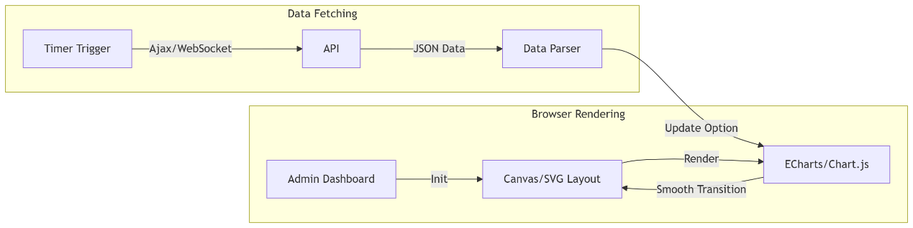
Fig4. Interface Visualization
3.5 Frontend-Backend Interaction Stability
Stable frontend-backend interaction is fundamental to system operation. Issues such as network anomalies, data transmission errors, and API call failures must be addressed.
First, communication between the frontend (Admin Web Interface, User Web Interface) and the backend uses the HTTP/HTTPS protocol to ensure data transmission security and reliability. Sensitive data like user passwords and payment information are encrypted using the MD5 algorithm to prevent data leakage.
Second, a comprehensive API error handling mechanism is designed. When a frontend API call encounters network disconnection, timeout, or backend error, the system immediately displays a clear error message to the user (e.g., "Network error, please try again later" or "API call failed, please contact administrator") and automatically retries the call (up to 3 times) to improve interaction success rates.
Third, dual frontend-backend data validation is implemented. Frontend validation checks input data formats (e.g., license plate format, reservation time range) to reduce invalid requests, while backend validation verifies data legitimacy (e.g., user permissions, space existence) to prevent illegal data entry into the database.
Fourth, stress testing is performed on backend APIs, simulating concurrent access by multiple users (up to 50 concurrent users) to test stability and response speed. API code is optimized based on test results to ensure stable system operation under peak concurrent loads.
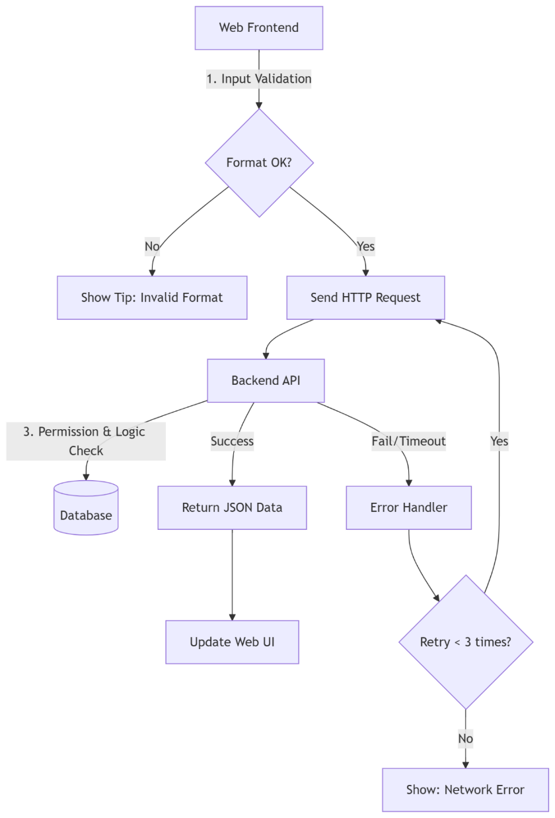
Fig5. Frontend-Backend Interaction
4. Division of Responsibilities
Admin Web Frontend Development: Responsible for admin backend interface design, data visualization chart implementation, dynamic parking space status refresh logic, and optimization of admin-side business function interactions and user experience.
BY: YeZhelin LvJiaxuan
User Web Frontend Development: Responsible for the user-facing website interface, responsive layout adaptation, reservation function interaction, parking record query, and development of the user profile/personal center module.
BY: ZhangCheng LiZehan
Backend and Database: Responsible for RESTful API interface development, business logic processing, MySQL database design and maintenance, WebSocket real-time push service setup, and unified data management across both ends.
BY: XvZiheng ZhuHongxu
Testing and Documentation: Responsible for functional testing, system performance optimization, and writing project technical reports and user manuals.
BY: PanJuanyou XvYanhao
5. References
[1] Qt Official Documentation. (n.d.). Qt 5.12 Official Documentation. Retrieved from https://doc.qt.io/archives/qt-5.12/
[2] MySQL Documentation. (n.d.). MySQL 8.0 Reference Manual. Retrieved from https://dev.mysql.com/doc/refman/8.0/en/
[3] Web Development Guides. (n.d.). W3Schools Web Development Tutorials. Retrieved from https://www.w3schools.com/
[4] Frontend-Backend Separation Architecture. (n.d.). Alibaba Cloud Architecture Design Guide. Retrieved from https://help.aliyun.com/

